Tab 1
<Moodle++>
Use-Case Specification
Version <1.0>

Revision History
Date | Version | Description | Author
<31/10/2025> | <1.0> | <Use-case Specification> | <Hoàng Đôn Thiện Hòa>

Table of Contents
1. Use-case Model ………………………………………………………………………. 4
2. Use-case Specifications ……………………………………………………………… 5
2.1 Use-case: (Case ..) …………………………………………………………………………… 5
2.2 Use-case: Create a new account ……………………………………………………………... 6
2.3 Use-case: (Case ..) ……………………………………………………………... 7
2.4 Use-case: (Case ..) ……………………………………………………………… 8
2.5 Use-case: (Case ..) ……………………………………………………………... 9

Task: Based on the requirements documented in the vision document, model use-cases of the system in forms of use-case diagrams (one or several diagrams). Each diagram includes use-cases, actors and relationships among them. You can use StarUML, Visio or another tool to design the use-case diagram. Place the diagram in the use-case specification document (see below).

1. Use-case Model
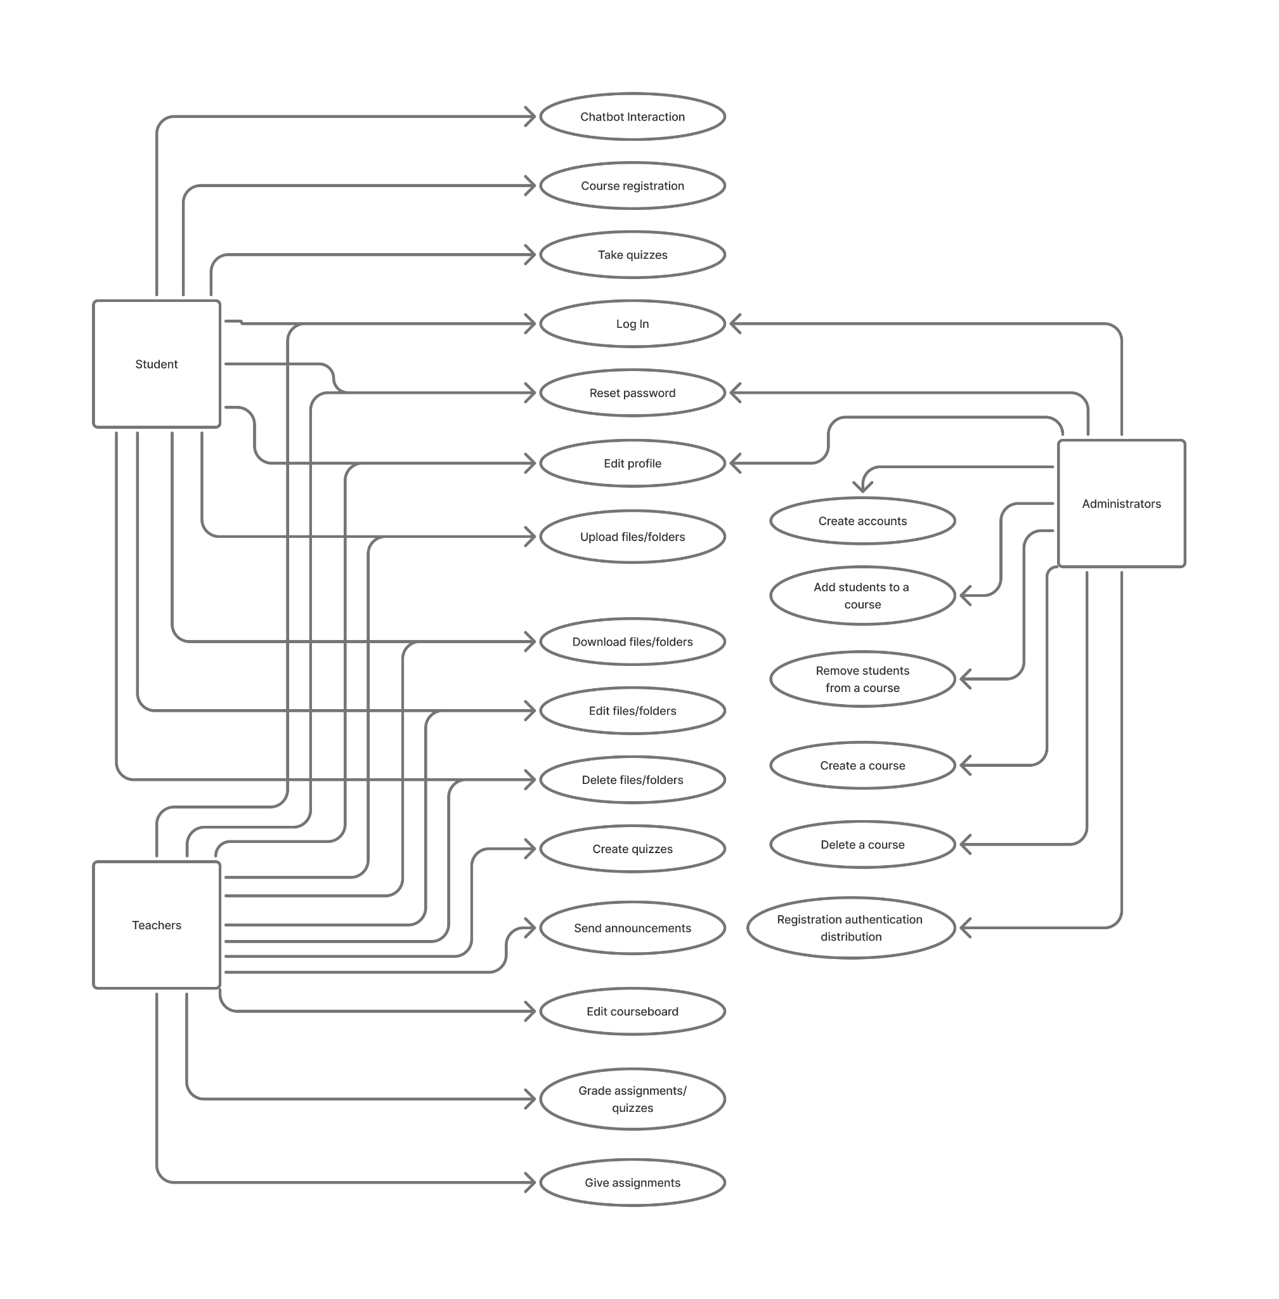

2. Use-case Specifications

2.1 Use-case: Login page
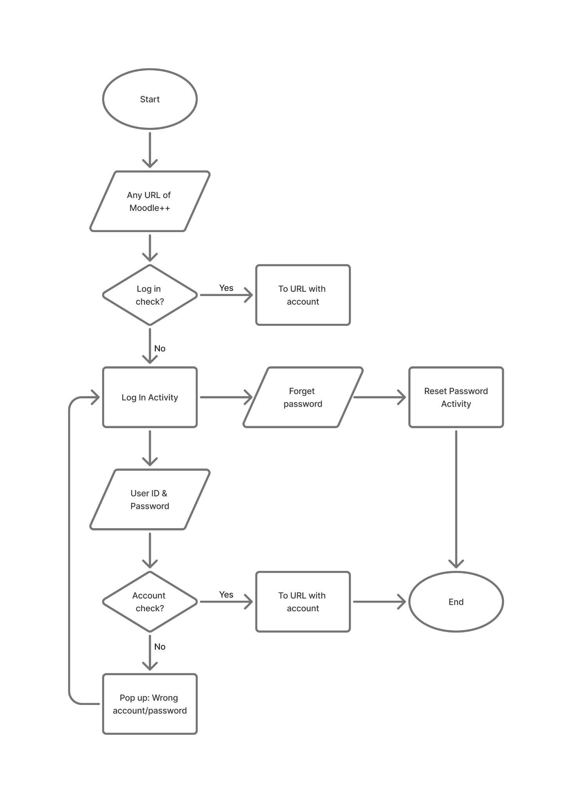
Use-case Name | Login page
Brief description | This use-case describes the flow of login on Moodle++ website.
Actors | Students, Teachers, Administrators.
Basic Flow | 1. The user enters any page related to Moodle.  2. The system checks if the user is logged in. If not, it redirects them to the login page.  3. At the login page, the user enters the User ID and the password into the provided text box.  4. Users clicks on ‘Log in’ to attempt logging into the website  5. If login is successful, the system logs the user in and redirects them to the page they were trying to reach (by default it’s the moodle homepage
Alternative Flows | Alternative flow 1: The user is already logged in  1. From #2 of the basic flow, the website displays the content with the logged account.  2. Continue step #5  Alternative flow 2: The login failed (either user ID or password is incorrect)  1. From #4 of the basic flow, the system loads the login page, along with the message “Either the user ID or password is incorrect”  2. Continue step #3  Alternative flow 3: The user clicks “Forget password?”  1. Start at use case …
Pre-conditions | The user goes to any url of Moodle++.
Post-conditions | The user successfully logs in to the website.

2.2 Use-case: Password reset
…
Use-case Name | Password reset
Brief description | This use-case describes the flow of the password reset on Moodle++.
Actors | Students, Teachers, Administrators.
Basic Flow | 1. At the password reset page, the user enters either the user ID or their school email.  2. The user clicks “Search” on the corresponding button (either next to the user ID  3. System displays the products found  4. User clicks ‘Add to cart’ button on the expected product  5. System adds a new product to shopping cart  6. System displays the quantity of all products in the cart to the user
Alternative Flows | Alternative flow 1: User cannot find products searched  1. From #1 of the basic flow, user enters another term  2. Continue step #2 in the basic flow  Alternative flow 2: Shopping cart has already had the product  1. From #5 of the basic flow, system increases the quantity of the product  2. Continue step #6  Alternative flow 3: …  1. …
Pre-conditions | The user clicks on “Forget password?” on the website.
Post-conditions | The user successfully adds a new item to the cart or increases the quantity of the existing item in the cart.

2.3 Use-case: Course Interaction
…
Use-case Name | Login
Brief description | This use-case describes the flow of login on Moodle++ web
Actors | Customer
Basic Flow | 1. At the homepage, the user enters keywords on the ‘Search’ field  2. Users clicks on ‘Search’ button to start searching a product  3. System displays the products found  4. User clicks ‘Add to cart’ button on the expected product  5. System adds a new product to shopping cart  6. System displays the quantity of all products in the cart to the user
Alternative Flows | Alternative flow 1: User cannot find products searched  1. From #1 of the basic flow, user enters another term  2. Continue step #2 in the basic flow  Alternative flow 2: Shopping cart has already had the product  1. From #5 of the basic flow, system increases the quantity of the product  2. Continue step #6  Alternative flow 3: …  1. …
Pre-conditions | User goes to homepage at (links webpage)
Post-conditions | The user successfully adds a new item to the cart or increases the quantity of the existing item in the cart.

2.4 Use-case:
…
Use-case Name | Login
Brief description | This use-case describes the flow of login on Moodle++ web
Actors | Customer
Basic Flow | 1. At the homepage, the user enters keywords on the ‘Search’ field  2. Users clicks on ‘Search’ button to start searching a product  3. System displays the products found  4. User clicks ‘Add to cart’ button on the expected product  5. System adds a new product to shopping cart  6. System displays the quantity of all products in the cart to the user
Alternative Flows | Alternative flow 1: User cannot find products searched  1. From #1 of the basic flow, user enters another term  2. Continue step #2 in the basic flow  Alternative flow 2: Shopping cart has already had the product  1. From #5 of the basic flow, system increases the quantity of the product  2. Continue step #6  Alternative flow 3: …  1. …
Pre-conditions | User goes to homepage at (links webpage)
Post-conditions | The user successfully adds a new item to the cart or increases the quantity of the existing item in the cart.

2.5 Use-case:
…
Use-case Name | Login
Brief description | This use-case describes the flow of login on Moodle++ web
Actors | Customer
Basic Flow | 1. At the homepage, the user enters keywords on the ‘Search’ field  2. Users clicks on ‘Search’ button to start searching a product  3. System displays the products found  4. User clicks ‘Add to cart’ button on the expected product  5. System adds a new product to shopping cart  6. System displays the quantity of all products in the cart to the user
Alternative Flows | Alternative flow 1: User cannot find products searched  1. From #1 of the basic flow, user enters another term  2. Continue step #2 in the basic flow  Alternative flow 2: Shopping cart has already had the product  1. From #5 of the basic flow, system increases the quantity of the product  2. Continue step #6  Alternative flow 3: …  1. …
Pre-conditions | User goes to homepage at (links webpage)
Post-conditions | The user successfully adds a new item to the cart or increases the quantity of the existing item in the cart.

